**Probability Prediction**   
**of finding Spotted Knapweed**   
**in Lac Du Bois**

by

Tanya Brouwers

Jasmine Ehlert

Matthew Francis

Nicole Rien

ECOLOGICAL MODELLING: FINAL PROJECT

THOMPSON RIVERS UNIVERSITY

ENVS 5480 / NRSC 4480

March.17/2024 - April.10/2024



Study Site shown to the Northwest of the City of Kamloops in the Lac du Bois grassland

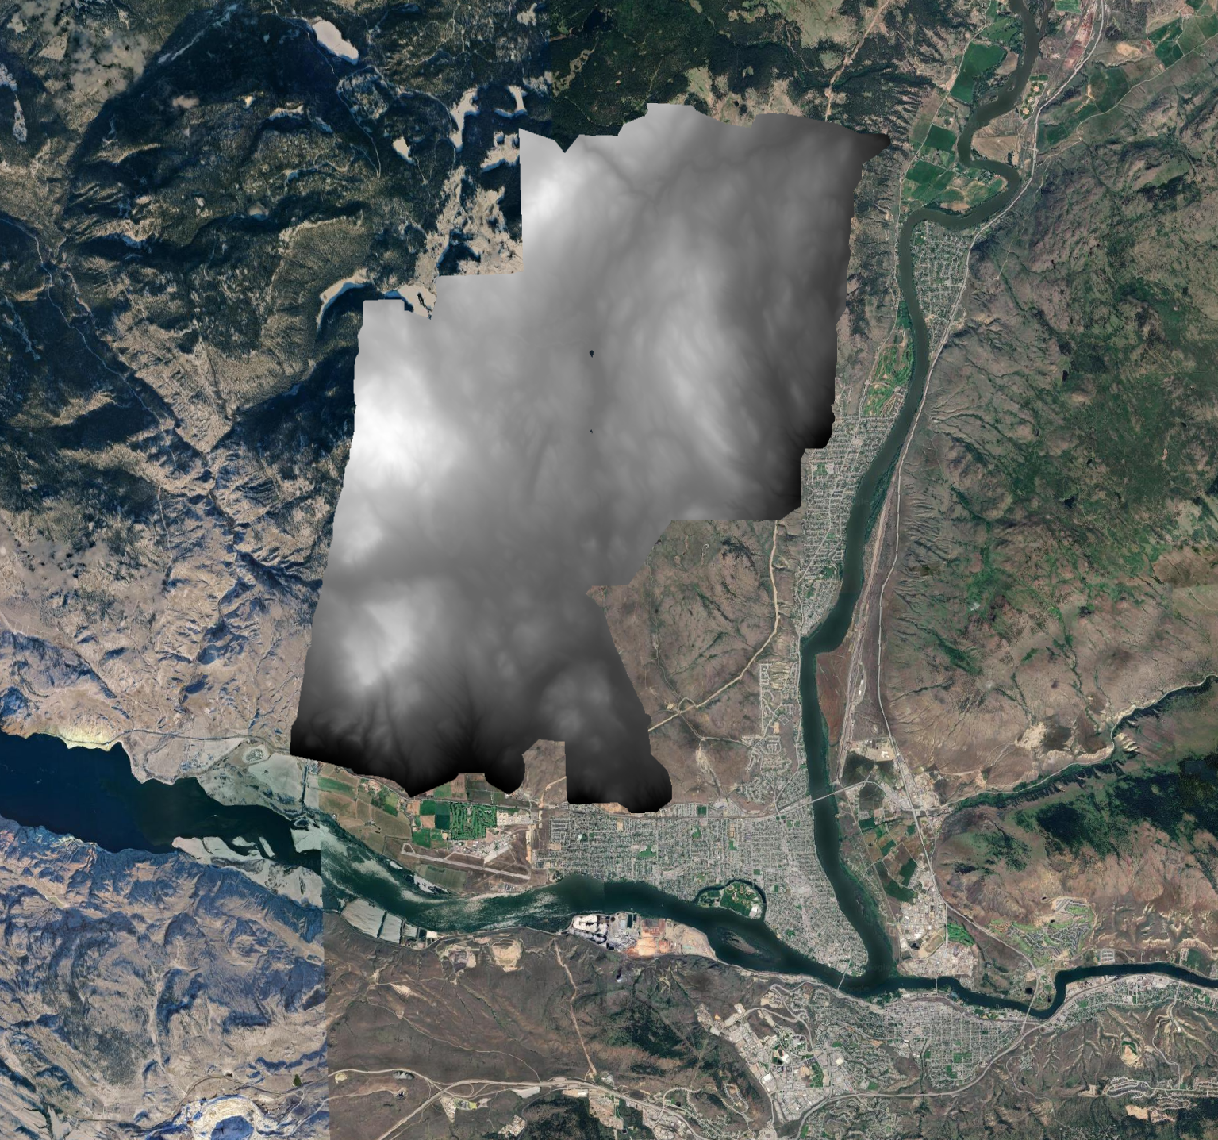

**Introduction**

Spotted knapweed (*Centaurea stoebe ssp. micranthos*) has emerged as a formidable invasive species across various ecosystems in British Columbia (BC), challenging the sustainability and health of these environments (BC Ministry of Agriculture, 2002). Characterized by its resilience and prolific reproduction capabilities, a single spotted knapweed plant can produce thousands of viable seeds, enabling rapid propagation and domination over native vegetation (NCC, 2024; Sheley, 2017). This invasive forb's ability to outcompete indigenous plant species not only disrupts local biodiversity but also alters habitat structures, affecting the overall ecological balance.

Parks and protected regions, with their rich biodiversity and ecological significance, have been particularly impacted, necessitating immediate and effective management strategies to curb the spread of this invasive species (ISCBC, 2023). The Lac Du Bois Grasslands Protected Area, a biodiversity hotspot within BC, has witnessed an alarming increase in spotted knapweed abundance (Singh et al., 2022). This proliferation has prompted researchers and conservationists to prioritize the understanding of the ecological niches that spotted knapweed can exploit. Such knowledge is crucial for developing targeted management practices aimed at mitigating the plant's expansion and preserving the ecological integrity of affected regions.

In response to this growing problem, our study focuses on the development of a predictive map detailing the probable distribution of spotted knapweed within the Lac du Bois Grasslands Protected Area. This map aims to identify areas at high risk of invasion, leveraging extensive data accumulation and sophisticated spatial analysis. It incorporates LIDAR metrics along with R-based advanced statistical and machine learning techniques to enhance its accuracy and reliability. By understanding the patterns of spread and preferred habitats of spotted knapweed, our research contributes to the strategic planning of intervention measures.

**Methods**

A provided lidar data set was processed in the program R to generate a digital elevation model (DEM). To generate the DEM from the lidar data it had to be tiled into smaller units for more efficient processing in R (LidR, 2024). The lidar files data points were then classified for the ground points of each tile. The DEM was processed from the classified set of ground data points and the file was saved as a TIFF file. The generated DEM file contains all the data of the points associated with ground and can be used to generate a variety of different layer files based on the points classified as ground. SAGA-GIS, with R, was used to post process the DEM file.

The SAGA-GIS software was connected to our R script through Rsagacmd to allow script in R to process and extract the terrain layers. There are many possible terrain layers that can be generated through SAGA-GIS and the layers need to be initially selected based on the final model desired. For our model we generated slope, aspect, MRVBF, MRRTF, TWI, TRI, TPI, SCA, TCA, and topographic openness.

The processed DEM with associated layers was then used to truth the presence or absence of spotted knapweed in the Lac du Bois grassland. The DEM delineates the area of interest (AOI). Polygons were created over this AOI to segment it into smaller units for analysis. The analysis of each polygon was done at a centroid of each polygon to avoid long processing times and reduce volume of data produced.

The probability model was then generated by incorporating all the previously extracted present or absent polygon data. The data was tuned, and the probability model was generated to make a confusion matrix of the resulting present and absent polygons. A variable importance graph was created by plotting the importance of the best learner. The Shannon Entropy was measured for the probability of each pixel to measure the uncertainty where the model may exhibit weak predictions. The probability layers were used for the model predictions to create a heat map style image of the presence and absence of knapweed in AOI.

**Results**

The best model parameters were determined by evaluating two available msrs (measures) under the classif task type. These included the Multiclass Brier Score and the AUC (Area under the Receiver Operating Characteristic (ROC) Curve). These were used to measure the performance of the model. The aggregated scores for classif.auc was 0.6459 which indicates a moderate discriminative performance, to distinguish between positive and negative instances. The score for classif.bbrier had a score of 0.2436 which indicates the accuracy of probabilistic predictions.

While defining performance metrics for model evaluation, the results of retrieving the msr information included a false value for minimizing the classif.auc and the classif.bbrier was true for minimizing. Maximizing the AUC is desired because higher values suggest better model performance. Minimization of the Brier score is preferred for better model calibration. Therefore the best learner was chosen based on maximizing the AUC.

**Variable Importance Metrics**

Once the best learner was chosen, the importance of each variable was plotted. Figure 1 describes the variable importance from most important to least important. This graph describes the relative contribution or how influential each variable is when predicting the target variable of the presence of spotted knapweed. The topographic openness had the highest importance with a value over 30. This attribute pertains to how visible or exposed the area is to the surrounding terrain. The slope variable had the lowest importance with a value of approximately 12.

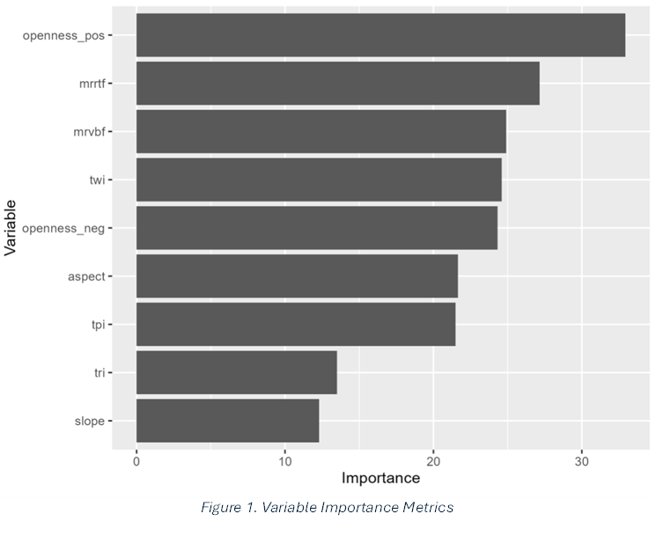

Figure 1. Variable importance metrics

**Entropy**

The Shannon Entropy was calculated for each pixel of the Lac Du Bois area to understand the uncertainty. Areas of weak predictions have high entropy values which can be seen in Figure 2 illustrated with blue values. Observations show that much of the model has weak predictions with entropy values near 70%.

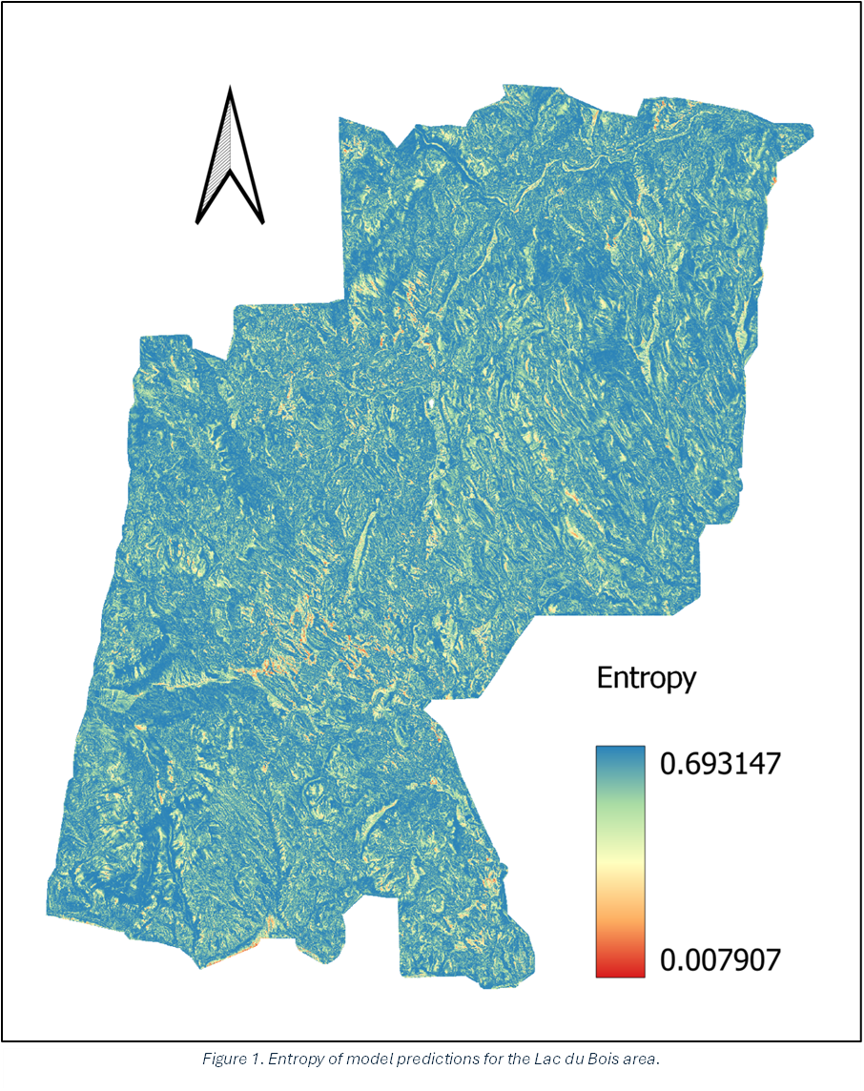

Figure 2. Entropy of model predictions for the Lac du Bois area.

**Confusion Matrix**

The confusion matrix describes the performance of the model. In the table below, the results show 207 true positives; 147 false positives; 196 true negatives; and 132 false negatives.

Table 1. Confusion matrix of model performance data

|  |  |  |  |
| --- | --- | --- | --- |
|  | truth | TRUE | FALSE |
| response |  |  |  |
| TRUE |  | 207 | 147 |
| FALSE |  | 132 | 196 |

In order to assess the accuracy of the results, the following calculation was used.

Accuracy = Number of Correct Predictions

Total Number of Predictions

.590 = 207+196

207+147+196+132

Therefore the accuracy of the model is 59%, which means the model incorrectly classifies 41% of the occurrences of the dataset.

**Prediction Map of Spotted Knapweed within Lac Du Bois**

The final predictive map of the model shown in Figure 3 illustrates the locations of high and low probabilities of locating spotted knapweed within Lac Du Bois. Probability of 1 indicates 100%. The areas of high probability appear to occur on sloped areas with southwest facing aspect, and alternatively away from valley bottoms, plateaus and ridges.

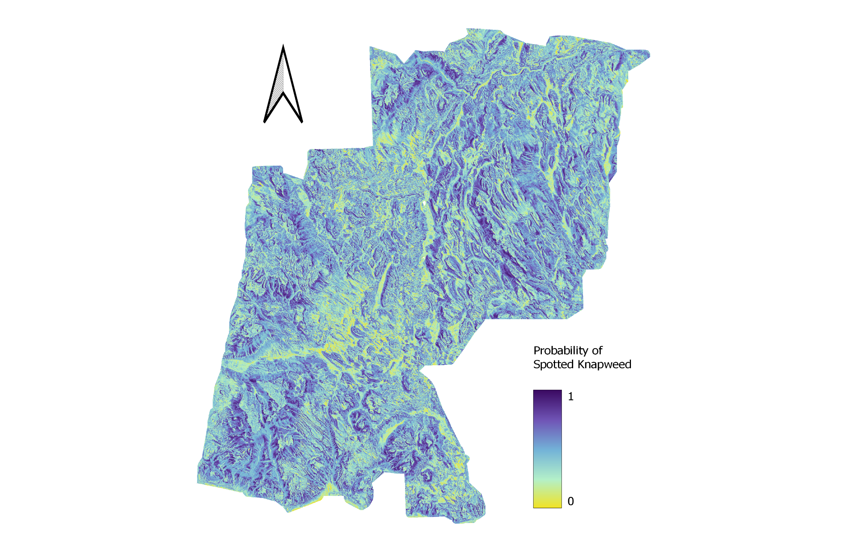

*Figure 3. Predictive map of the probability of locating spotted knapweed within Lac du Bois.*

**Discussion**

The probability model was trained using the learner with the highest AUC error. The AUC error was 0.64 indicating the model has some predictive ability but is generally not reliable. The unreliability of the model likely led to high errors within the predictive map, and high entropy for the sample site. We may be able to improve the predictive value of our model, and reduce entropy by increasing our training data, or collecting more field data.

The predictor variables had high variability of importance with the highest scoring 30, and the lowest scoring 12. This variability may indicate that some of the variables used did little to contribute to the overall predictive power of the model. Looking for additional variables to use, or removing low importance variables may help to improve the accuracy of predicting where we might find spotted knapweed in the future.

The areas where our model had low entropy, coincided with areas that had a low probability of finding spotted knapweed. This indicates our model is more reliable when predicting areas where spotted knapweed is absent compared to where it is present. This may just be a coincidence, or it may indicate the predictive variables we used were more well suited to predict where spotted knapweed cannot grow. Looking at a wider range of predictor variables and increasing the amount of training and testing data we use could help create a better predictive model in the future attempts.

Our predictive map can help indicate where spotted knapweed may be found within the Lac Du Bois grasslands area. As the spread of this invasive weed is an ongoing management concern, finding areas that are likely to contain this weed is of utmost importance to mitigation efforts.

References

BC Ministry of Agriculture, Food and Fisheries (2002, January 1). *Guide to weeds in British Columbia*. Retrieved April 7, 2024, from <https://www2.gov.bc.ca/assets/gov/environment/plants-animals-and-ecosystems/invasive-species/guidance-resources/guidetoweeds.pdf>

Invasive Species Council of BC (2023, January 1). *Invasive Plant Spotted Knapweed*. Retrieved April 7, 2024, from <https://bcinvasives.ca/invasives/spotted-knapweed/#:~:text=They%20choke%20out%20desirable%20forage,Provincial%20Priority%20Invasive%20Species%20List>.

Nature Conservancy Canada (n.d.). *Spotted knapweed*. Retrieved April 7, 2024, from <https://www.natureconservancy.ca/en/what-we-do/resource-centre/invasive-species/spotted-knapweed.html>

Sheley, R. L., Jacobs, J. S., & Carpinelli, M. F. (1998). Distribution, biology, and management of diffuse knapweed (Centaurea diffusa) and spotted knapweed (Centaurea maculosa). *Weed technology*, *12*(2), 353-362.

Singh, J. P., Kuang, Y., Ploughe, L., Coghill, M., & Fraser, L. H. (2022). Spotted knapweed (Centaurea stoebe) creates a soil legacy effect by modulating soil elemental composition in a semi-arid grassland ecosystem. *Journal of Environmental Management*, *317*, 115391.

The LIDR package. (n.d.). Retrieved April 8, 2024, from <https://r-lidar.github.io/lidRbook/>

**Appendix**

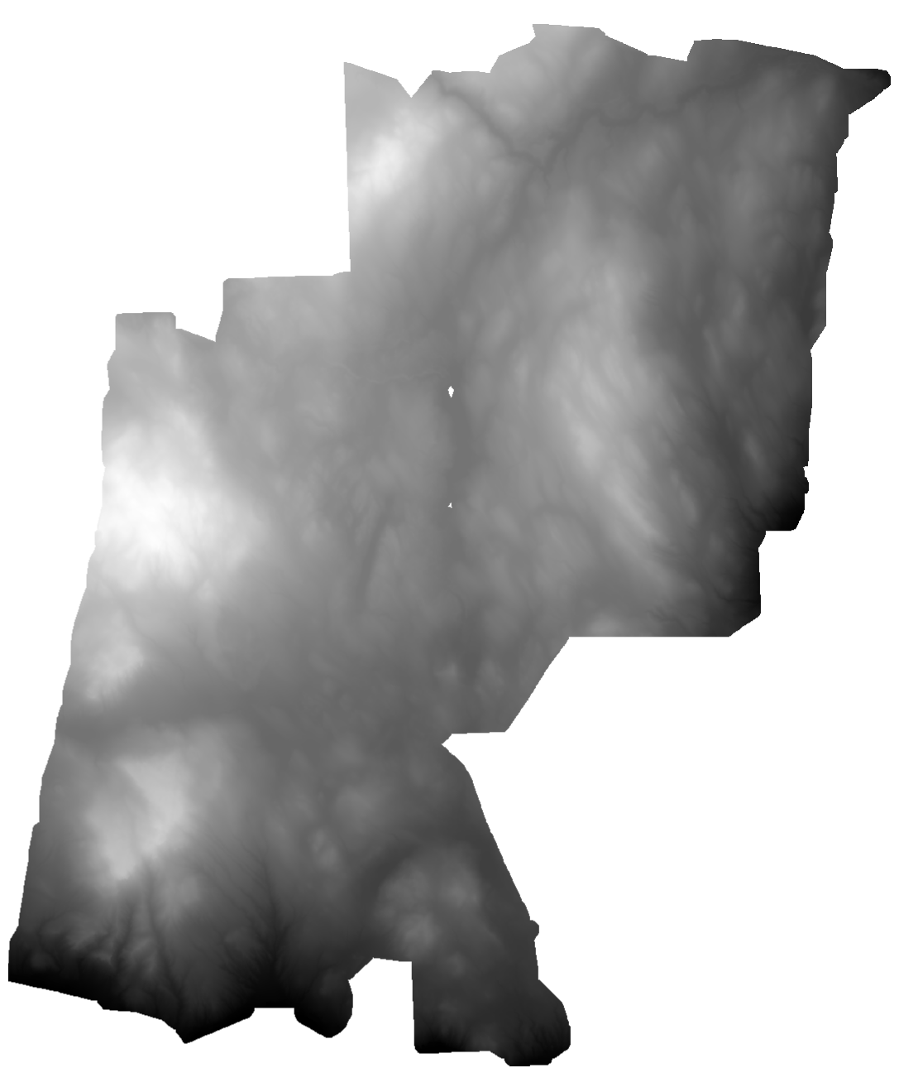Figure 4. DEM generated from a 5m resolution of a very fun lidar package